


Faculty of nursing Medical Surgical Nursing Medical Surgical II Course Surgical rotation 2022/2023

Anorectal Disorders (Evidence-Based Revised Teaching Edition)
REVISION LEGEND
Blue text = revised/corrected original content.
Green text = newly added/expanded evidence-based content and nursing rationale.
Evidence alignment note: updated conservatively per current ASCRS/ACG/ESCP guidance and contemporary nursing standards.

Prepared by:
Dr/ Asmaa Abdel Hafez Dr/ Yasser Mahmoud

1

- Course outline (updated):

- Introduction
- Anatomy and physiology of the anal canal.
- Epidemiology and burden of benign anorectal disorders.
- Common anorectal disorders addressed in this chapter:
  - Anorectal Abscess
  - Anal Fistula
  - Anal Fissure
  - Hemorrhoids (piles)
- Pathophysiology of each condition.
- Clinical manifestations of each condition.
- Complications of each condition
- Conservative, office-based, and surgical management of each condition.
- Nursing care priorities for each condition.
- Health education and discharge teaching for each condition.
- Common nursing diagnoses in anorectal disorders.

Introduction
Benign anorectal disorders are common causes of pain, bleeding, discharge, perianal swelling, pruritus, and altered bowel habits. Patients frequently delay care because of embarrassment or fear of examination; therefore, nurses play a key role in assessment, education, symptom relief, and timely referral.
From an evidence-based perspective, symptom pattern and severity should guide triage. Rectal bleeding, severe pain, fever, sepsis signs, fecal incontinence, and unexplained weight loss require prompt clinical evaluation and targeted investigation.

Anatomy and physiology of the anal canal
- gastrointestinal tractThe anal canal is the terminal 3–4 cm of the gastrointestinal tract, extending from the anorectal junction to the anal verge.
- Continence depends on coordinated function of the internal anal sphincter (involuntary smooth muscle), external anal sphincter (voluntary striated muscle), puborectalis, rectal compliance, stool consistency, and intact sensory pathways.
- Arterial supply is mainly from superior, middle, and inferior rectal arteries; venous drainage occurs via corresponding rectal venous plexuses with porto-systemic connections.
- Innervation is autonomic above the dentate line and somatic below the dentate line (inferior rectal branch of the pudendal nerve), which explains pain differences between internal and external lesions.
- Anal sphincters:
- Internal sphincter: continuation of the circular smooth muscle of the rectum; contributes most resting anal pressure.

Sphincter hypertonia and ischemia are key mechanisms in chronic anal fissure pathophysiology.
- External sphincter: voluntary striated muscle complex that supports squeeze pressure and continence.
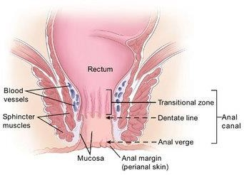

Common anorectal disorders
Additional benign anorectal disorders relevant for differential assessment include pruritus ani, pilonidal disease, fecal incontinence, and rectal prolapse.
- Anorectal Abscess
- Anal Fistula
- Anal Fissure
- Hemorrhoids (piles)

Anorectal abscess
An anorectal abscess is an acute suppurative infection in the perianal/perirectal region, most often arising from infected anal glands (cryptoglandular origin).

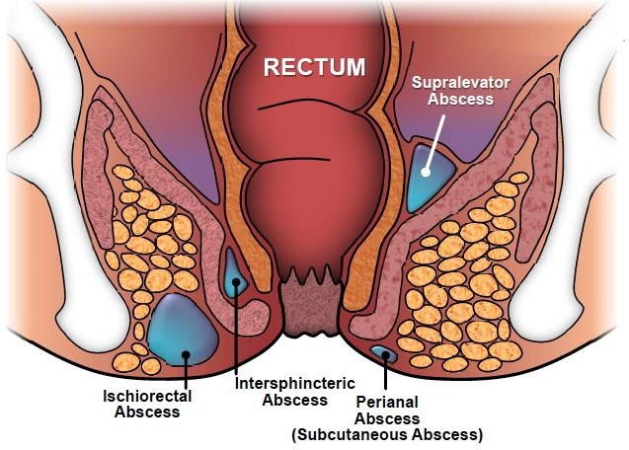

Pathophysiology of anorectal abscess
Obstruction and infection of anal glands allow pus to track through intersphincteric and adjacent spaces, producing perianal, ischiorectal, intersphincteric, or supralevator abscess patterns.
Delayed drainage increases risk of tissue spread, systemic infection, and later fistula formation.
Mixed aerobic and anaerobic flora are common; antimicrobial selection, when indicated, should follow local guidance and patient risk profile.
A substantial proportion of patients may later develop fistula-in-ano; follow-up is therefore important after acute treatment.
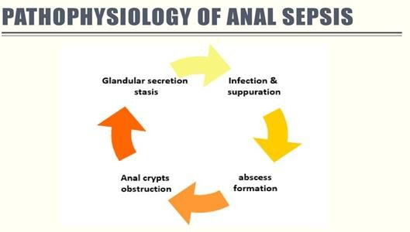

Risk factors
Crohn disease, diabetes, immunosuppression, smoking, prior anorectal infection/surgery, and local trauma increase risk and complexity.

Clinical features
- Constant throbbing anorectal pain, often worsened by sitting, defecation, or movement.
- Localized tender swelling, erythema, warmth, and fluctuance (if superficial).
- Purulent drainage may occur spontaneously if the abscess drains externally.
- sepsisFever, malaise, tachycardia, or sepsis features suggest deeper infection and require urgent care.

Complications
  - Fistula-in-ano
  - Recurrent perianal sepsis
  - Cellulitis or necrotizing soft tissue infection (rare but life-threatening)
  - Systemic sepsis in high-risk patients

Management
- Assessment includes focused history, perianal inspection, and selective digital rectal examination when tolerated; deep/complex disease may require imaging (often MRI).
- Antibiotics are not routine after uncomplicated drainage; they are considered when there is cellulitis, systemic infection, immunosuppression, valvular heart disease risk, or significant comorbidity.
- incision andabscess drainageDefinitive treatment is prompt incision and drainage; timing should not be unnecessarily delayed.
- Evaluate for associated fistula during follow-up, especially if symptoms persist or recur.

Nursing care
- Provide clear hygiene teaching: gentle cleansing, careful drying, frequent pad changes, and skin protection from moisture-associated injury.
- Recommend breathable, non-restrictive cotton undergarments and avoidance of prolonged moisture exposure.
- Warm sitz baths may improve comfort; reinforce that they are adjuncts, not definitive treatment for undrained abscess.

Anal fistula
An anal fistula is an abnormal epithelialized tract connecting the anal canal/rectum to perianal skin (or, less commonly, adjacent organs).

Risk factors
- Prior anorectal abscess (most common antecedent)
- Crohn disease and chronic inflammatory conditions
- Anorectal trauma or prior anorectal surgery
- Radiation, malignancy, tuberculosis, or obstetric injury in selected cases

Clinical features
- Persistent or recurrent purulent drainage, cyclical pain/swelling, perianal irritation, and possible passage of gas/stool through an abnormal opening depending on tract location.

Complications
- Recurrent infection/abscess
- Continence disturbance if sphincter injury occurs
- Recurrence after treatment, especially in complex fistulas

Management
- Diagnosis: inspection and examination under anesthesia when needed; MRI pelvis and/or endoanal ultrasound are useful for complex tracts.

- Medical therapy has a limited role in cryptoglandular fistula but is important in Crohn-related disease (e.g., biologic-based strategies per specialist guidance).
- Surgery is individualized to eradicate sepsis while preserving continence: options include fistulotomy (selected low/simple tracts), seton techniques, advancement flap, LIFT, and other sphincter-sparing approaches.

Nursing care
- Monitor drainage characteristics, wound status, pain pattern, and infection signs; escalate worsening findings promptly.
- Teach daily perineal cleansing, careful drying, and adherence to follow-up plans.
- Encourage breathable clothing and skin-barrier protection when drainage is persistent.
- Sitz baths may reduce discomfort in the postoperative and chronic-drainage setting.
- After packing/seton procedures, reinforce ordered wound care and return precautions (fever, severe pain, urinary retention, bleeding).
- Promote bowel regularity and avoidance of straining.
- Support high-fiber intake, adequate hydration, and prescribed stool-softening regimens as indicated.
- Discourage unsupervised laxative overuse; tailor bowel plans to stool consistency and symptoms.

Anal fissure
An anal fissure is a longitudinal tear in the anoderm, most commonly at the posterior midline. Acute fissure lasts <6 weeks; chronic fissure persists >6 weeks and may show a sentinel tag or exposed internal sphincter fibers.
Acute – present for < 6 weeks. Chronic – present for > 6 weeks.
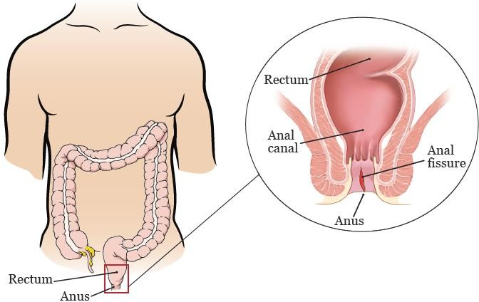

Risk factors
- Constipation and passage of hard stool
- Low fluid intake and poor stool hydration
- Inflammatory bowel disease (especially Crohn disease)
- Childbirth-related trauma and pelvic floor injury
- Repeated local trauma, including forceful defecation
- Frequent stimulant-laxative misuse can worsen bowel dysfunction and should be corrected with supervised bowel management.

Clinical features
- Severe tearing pain during and after defecation (often lasting minutes to hours).
- Small-volume bright red bleeding on wiping or stool surface.
- Post-defecation burning, pruritus, and sphincter spasm may occur.

Complications
Persistence as chronic fissure with recurrent pain and defecation avoidance
- Secondary local infection (uncommon)
- Sentinel skin tag and hypertrophied anal papilla in chronic disease
- Rarely, fistula formation

Management
- Diagnosis is primarily clinical by gentle inspection; forceful digital rectal examination is usually deferred in severe acute pain.

Medical management
- First-line care includes stool normalization (fiber, hydration, osmotic softeners if needed), pain control, and bowel-habit retraining.
- Osmotic laxatives/stool softeners can be used when dietary measures alone are insufficient.
- Short-course topical anesthetic may provide symptom relief before bowel movements.
- Warm sitz baths can reduce internal sphincter spasm and improve comfort.

- If symptoms persist, topical vasodilator therapy (e.g., glyceryl trinitrate or diltiazem) is recommended per current guidance; monitor for adverse effects such as headache with GTN.

Surgical management
Surgery is considered for chronic or refractory fissure after optimized medical therapy.
Lateral internal sphincterotomy is effective in selected patients; continence risk must be discussed and individualized alternatives considered.

Nursing care
- Assess pain trend, bowel pattern, and hydration; reinforce adherence to the bowel plan to prevent re-tearing.
- Teach gentle cleansing, drying, and avoidance of irritant products.
- Encourage breathable cotton undergarments and moisture control.
- Reinforce safe sitz-bath use (clean basin, warm—not hot—water, timed sessions).
- Teach medication adherence and adverse-effect monitoring.
- Coach straining avoidance and correct toileting posture/habits.
- Promote sustained fiber and fluid intake based on tolerance.
- Discourage self-directed prolonged laxative use without clinical follow-up.

Hemorrhoidal disease
Hemorrhoidal disease refers to symptomatic enlargement and distal displacement of normal anal vascular cushions.

Hemorrhoids are classified as:
Internal hemorrhoids: originate above the dentate line and are graded by prolapse severity.
External hemorrhoids: arise below the dentate line and may present with painful thrombosis.

Goligher grade (internal hemorrhoids) | Description
Grade I | Remain in the anal canal (no prolapse).
Grade II | Prolapse with straining/defecation and reduce spontaneously.
Grade III | Prolapse with straining/defecation and require manual reduction.
Grade IV | Irreducible prolapse; may become incarcerated/strangulated.

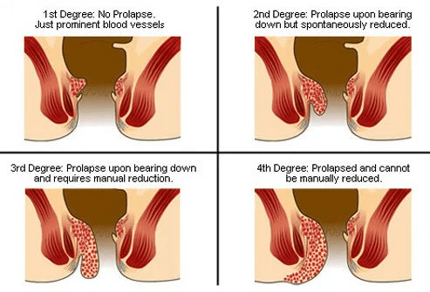

Risk factors
- Excessive straining and chronic constipation
- Advancing age and connective-tissue support changes
- Increased intra-abdominal pressure (e.g., pregnancy, chronic cough, ascites)
- Low-fiber dietary pattern, prolonged toilet sitting, and other contributors to bowel dysfunction

Clinical features
- Painless bright red bleeding during or after defecation (typically coating stool or on tissue rather than mixed within stool).
- Pruritus/soiling related to mucus leakage and irritation.
- Sensation of prolapse, fullness, or palpable perianal lump.
- Acute thrombosed external hemorrhoid causes severe localized pain and tender swelling; urgent assessment may be required.

Complications
- Iron-deficiency anemia from chronic bleeding (uncommon)
- Thrombosis of external hemorrhoids
- Incarceration/strangulation in prolapsed internal hemorrhoids
- Ulceration or secondary infection in advanced untreated disease

Management
Evaluation includes focused history and anorectal examination; endoscopic assessment is considered when bleeding pattern or risk profile suggests alternate pathology.
Office-based procedures (for selected internal hemorrhoids) include rubber band ligation, infrared coagulation, and sclerotherapy.
- Infrared coagulation
- Bipolar or related coagulation methods (where available)
- Sclerotherapy can be considered for selected bleeding internal hemorrhoids.
- Procedure choice depends on symptom pattern, hemorrhoid grade, and local expertise.

Surgical treatment
- Rubber band ligation is typically an office procedure for grade I–III internal hemorrhoids.
- Excisional hemorrhoidectomy is generally reserved for high-grade prolapse, substantial external disease, or failure of office procedures.
- Stapled hemorrhoidopexy and hemorrhoidal artery ligation may be options in selected patients; discuss recurrence and pain profiles during shared decision-making.

Nursing care
- Teach perianal hygiene and moisture control to reduce irritation.
- Coach patients to avoid prolonged straining and excessive time on the toilet.
- Promote high-fiber eating patterns (whole grains, fruits, vegetables) and individualized bowel plans.
- Encourage adequate daily fluid intake unless contraindicated.
- Prevent constipation using diet, activity, and prescribed agents as needed.
- Use warm sitz baths for comfort; avoid very hot water and over-cleansing.
- Topical agents may provide short-term symptom relief; avoid prolonged unsupervised steroid preparations due to skin effects.
- Encourage early ambulation and activity as tolerated unless a specific postoperative order limits activity.

General patient education for anorectal conditions
- Patient education improves symptom control, treatment adherence, and confidence in self-management at home.
- Teach gentle cleansing with lukewarm water and careful drying; avoid fragranced wipes and harsh soaps.
- Avoid vigorous rubbing with toilet tissue; use soft, non-irritating materials.
- Explain safe sitz-bath technique and temperature checks to prevent thermal injury.
- After anorectal surgery, transient sphincter spasm and pain may occur, especially in the first 24–48 hours.
- Teach multimodal pain strategies (prescribed analgesics, local comfort measures, and bowel-softening plans) to reduce pain-related stool withholding.
- Sitz baths 2–4 times daily may reduce soreness and sphincter spasm in many patients.
- Topical anesthetics can be used selectively for short-term local discomfort as prescribed.

Nursing practice points (added):
• Prioritize red-flag triage: hemodynamic instability, sepsis signs, uncontrolled pain, urinary retention, or significant ongoing bleeding require urgent escalation.
Suggested further reading / guideline sources
• ASCRS Clinical Practice Guideline: Management of Hemorrhoids (2024 update).
• ASCRS Clinical Practice Guideline: Anal Fissure (2023).
• ASCRS Clinical Practice Guideline: Anorectal Abscess, Fistula-in-Ano, and Rectovaginal Fistula (2022).
• ACG Clinical Guideline: Management of Benign Anorectal Disorders (2021).
• Additional ASCRS/ESCP guidance on fecal incontinence, rectal prolapse, and pilonidal disease.
• Document stool pattern (frequency, Bristol stool type, straining, urgency) and response to bowel regimen at each contact.
• Use trauma-informed communication to reduce embarrassment and improve follow-up adherence.
- Medication teaching should prioritize evidence-based bowel regimens, safe analgesia, and condition-specific topical agents; avoid unnecessary sedatives.
- Patients are usually more adherent when pain is adequately controlled and clear return precautions are provided.
Escalate care for fever, increasing pain/swelling, urinary retention, heavy bleeding, purulent discharge, or inability to pass stool/gas.
- When wet dressings are used, protect surrounding skin with barrier ointment to reduce maceration.
- Positioning, short walks, and pressure relief can reduce edema and discomfort based on patient tolerance.

Common nursing diagnoses with anorectal disorders

Constipation related to
Pain-related defecation avoidance, fear of painful stool passage, and inadequate bowel-habit support.

As evidenced by
Reduced stool frequency, passage of hard stool, abdominal distention, straining, and sensation of incomplete evacuation.

Nursing goal
Patient reestablishes and maintains a regular, comfortable elimination pattern.

PainAcute or chronic pain related to
Rectal tissue inflammation, edema, thrombosis, sphincter spasm, or postoperative tissue injury.

As evidenced by
Patient verbal report of pain, guarding behavior, facial grimacing, and activity limitation.

Nursing goal
Patient reports clinically meaningful pain reduction and improved functional comfort.
- Impaired comfort related to
Persistent anorectal pain, drainage, pruritus, and sleep disruption secondary to anorectal disease.

As evidenced by

Irritability, fatigue, restlessness, anxiety, and reduced participation in self-care activities.

Nursing goal
Patient reports improved comfort and ability to perform daily self-care.
Patient demonstrates knowledge of individualized comfort measures and warning symptoms requiring reassessment.

